BRAZIL TO TRINIDAD AND EQUATOR CROSSING

Photos from Equator crossing:

Pap egghead!

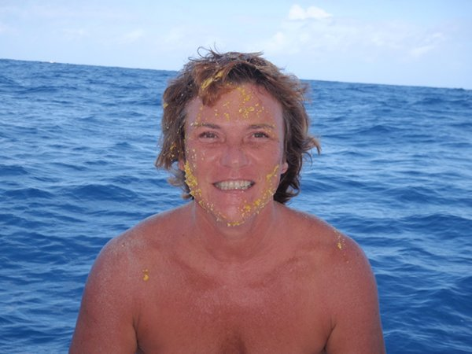

I had to kiss the flying fish! Eeuww.
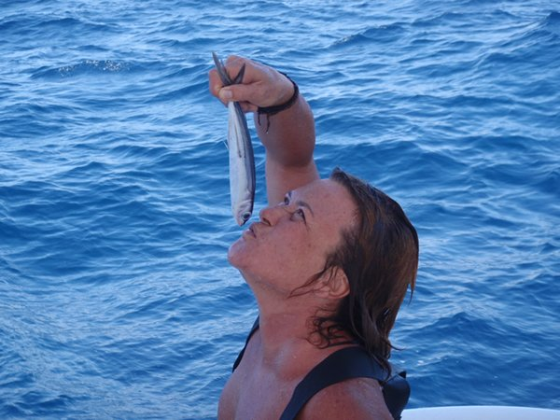
Offerings for King Neptune and a cookie for Queen Afrotitty!
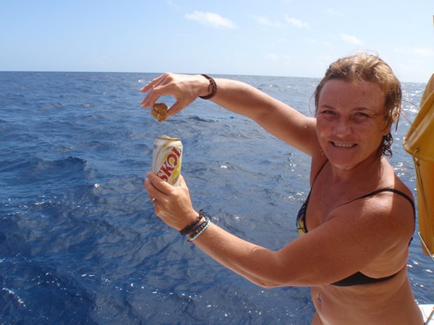
King Neptune
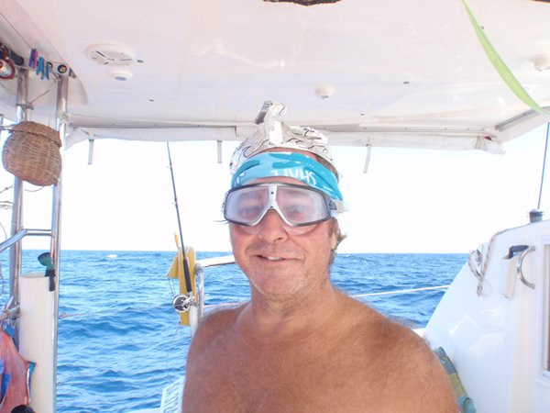

Making up to King Neptune ;)
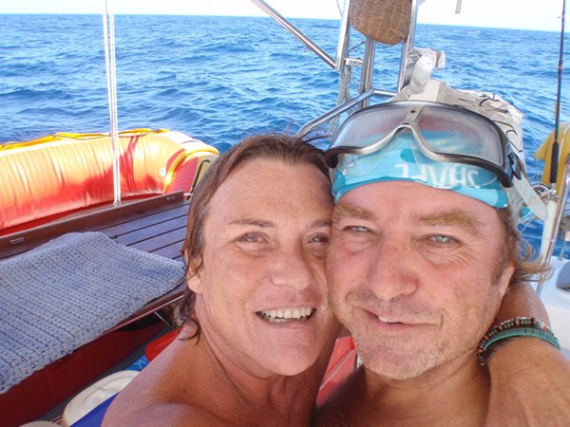

King Neptune being dragged across the Equator, so was I.
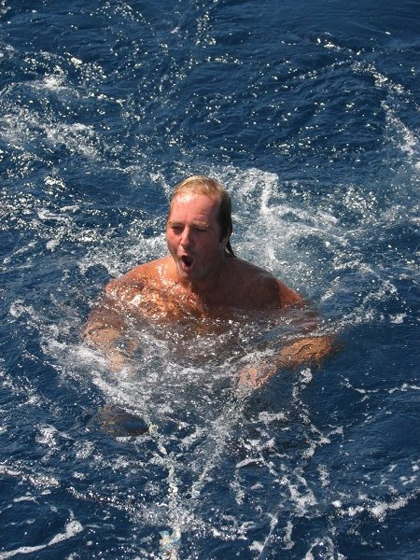

Iza was with us
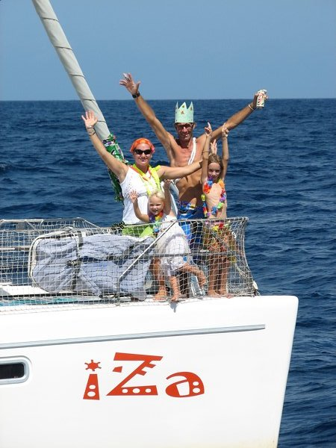

This bird landed and stayed 3 nights and days. We thought it was injured but then saw it flew off to eat and drink and came back.
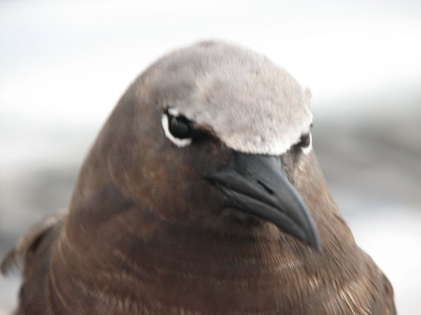

She was so tame we walked around her, opened and closed sails with much noise and she just watched, I thought she might step onto my hand but she just moved off out of reach!
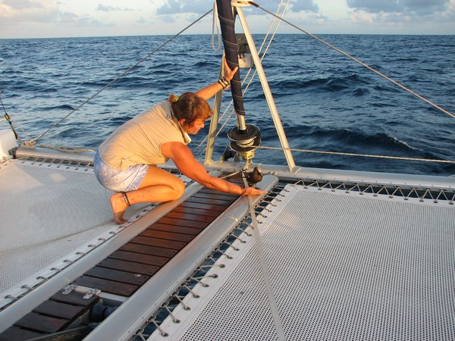
Birds first night.
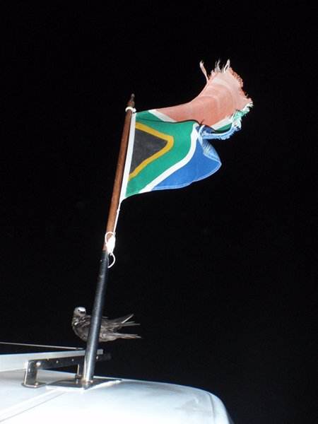

Being chased by a squall.
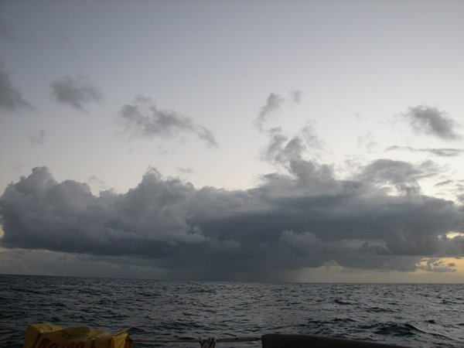

We caught a Yellow finn Tuna. They bleed a lot, Yuk!
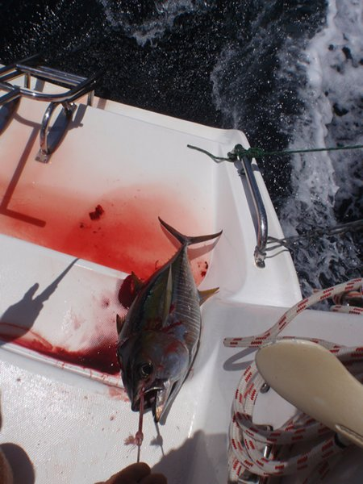

Getting ready for the pan.
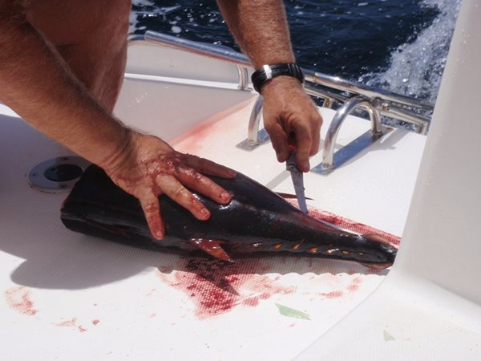

I see you

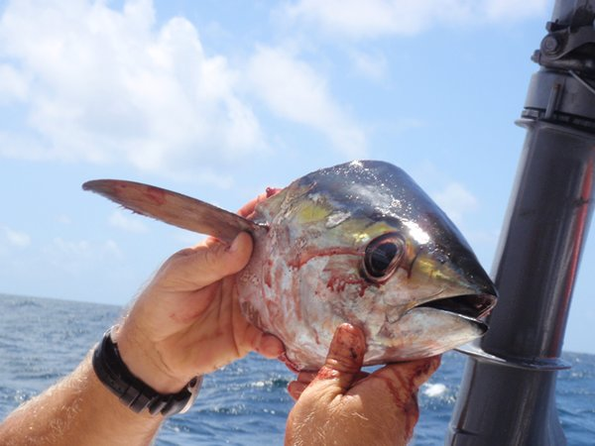

Dinner is served

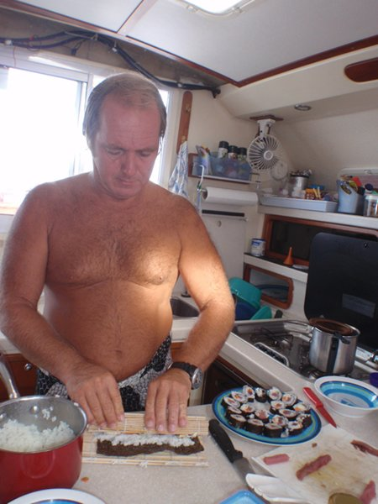

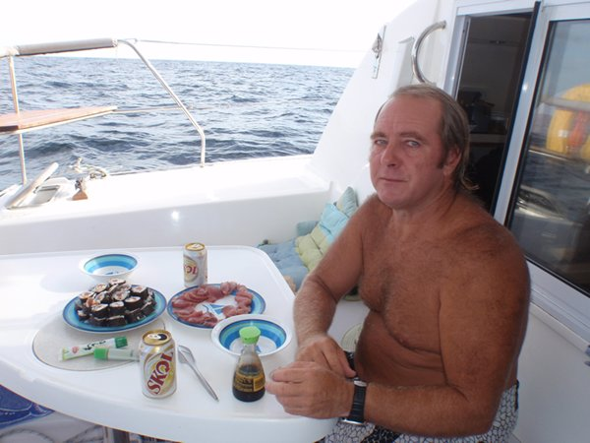

Sunset
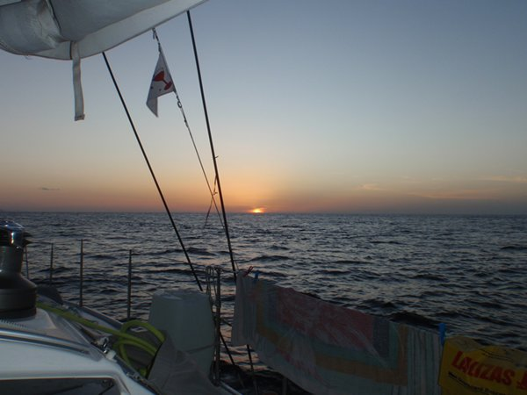

Putting up our courtesy flags for Trinidad
