Monday 14th May

It seems an age since I last had a chance to update our site . Sorry

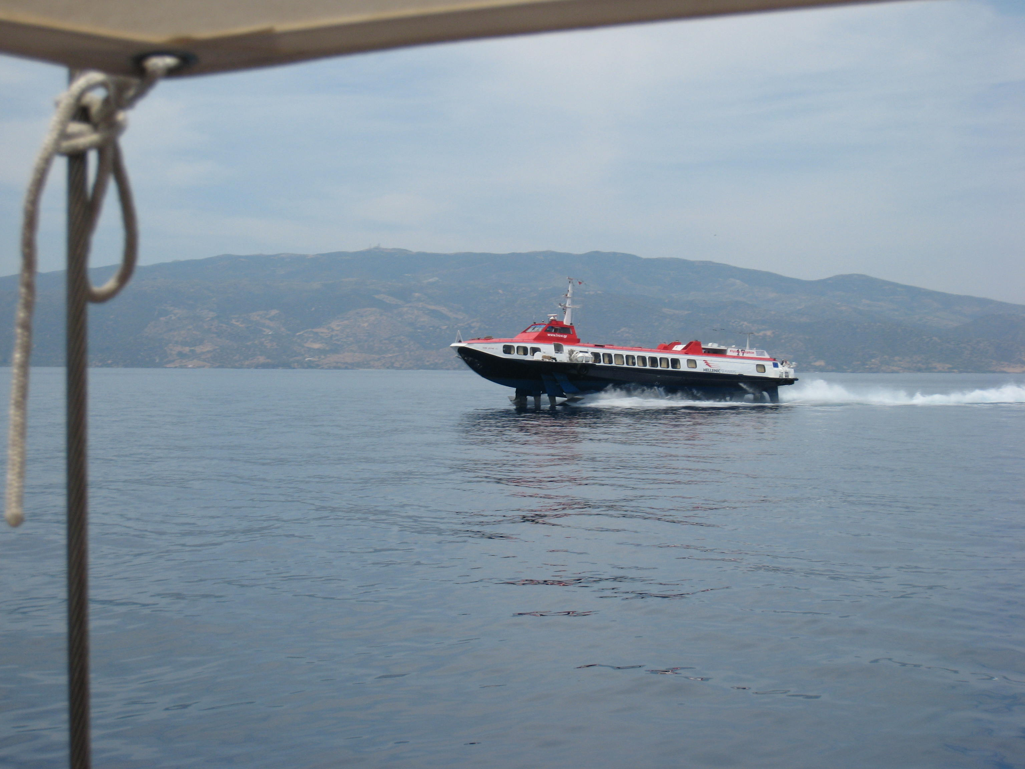

Sue arrived on Monday after an overnight flight from UK … Very tired but happy .

The Flying Dolphin that runs the ferry service from Pieraus is a most strange contraption, originally Russian but strengthened and with turbo diesel engines for the Med ferry work .. Several of them are over 20 years old ..

Sue had a sleep in the morning and we had a look around and had a relaxed dinner before a reasonably early evening .. It has been extremely hot out here, frequently into the early 30’s and I haven’t seen any rain since I arrived back this last time .Very tiring for we Brits .. !!

Here is Sues arrival .. Just to prove for her friends and work colleagues that she really is in Greece.

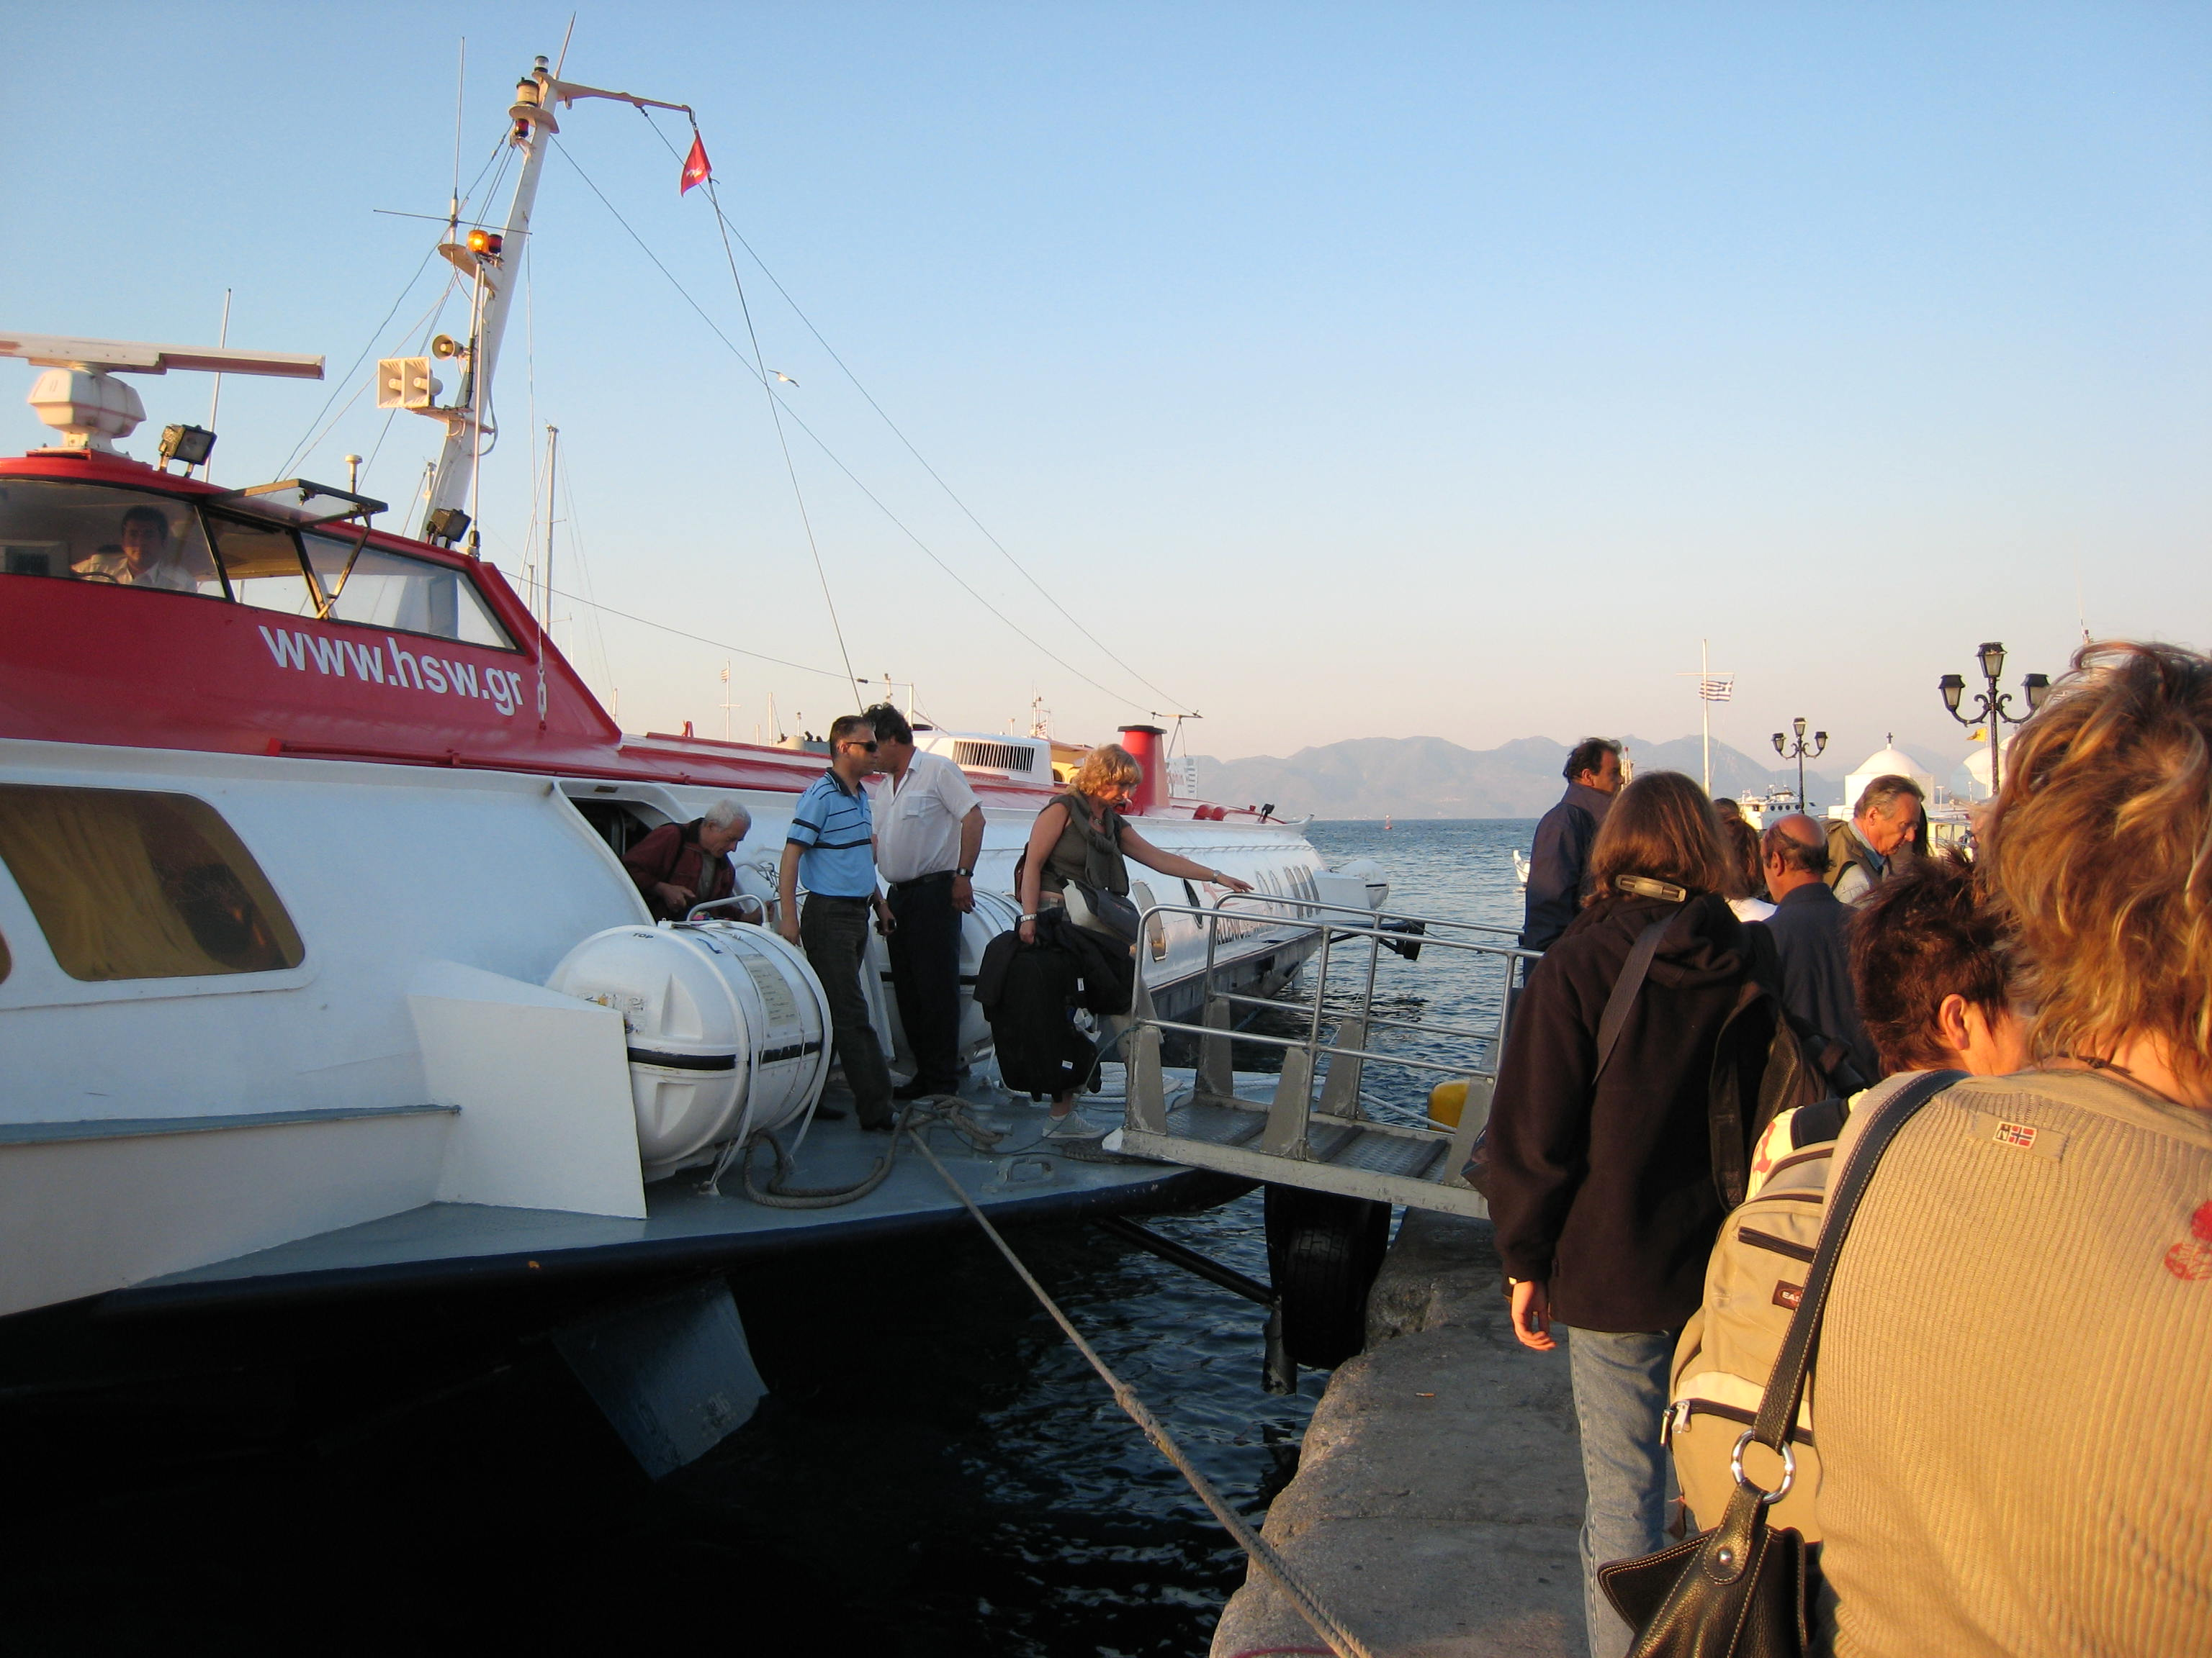

On Tuesday we started training for real .. Sue spent the day with Mellody, (George’s wife) learning all there is to know about navigation . !

I spent the Day with George (the Chief Instructor of the Aegean Sailing School) , finding our way around Quilombo, and finding out which ropes pulled what .!! George is doing a Crash shakedown course for the week , so that we discover some of Quilombos problems before we leave, and so that we have some idea how to sail her ..

