May 2009

Hi,we are in New Caladonia after a very pleasant sail up from New Zealand.It is only 900 miles but the stretch of water between New Zealand and the islands north is notorious for rough and windy conditions. Highs and Lows progress across the Tasman Sea and if you are unlucky a squash zone forms between them with very close isobars. However meteorlogical routers offer advice and it worked for us this time and we scuttled through the reef at Noumea with huge breakers either side of the pass before the next batch of winds swept by. Boats who missed our window are now only under way after a wait of 3 weeks .It is much warmer here and its back to shorts and tee shirts. New Zealand was much colder than anticipated!
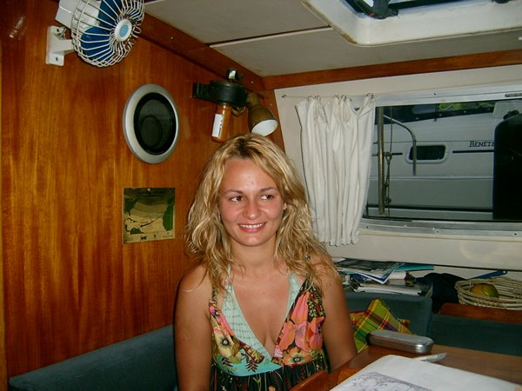
We were joined by a young Swiss lady called Andrea who wanted to ship up to the islands and try offshore sailing...she described the passage as a "retreat" as she claims to be a party animal and kept us entertained with her stories---she was an unusual backpacker having worked for 2 years in a swiss bank after uni,was not short of cash and plans to start a ma in business studies in Sept.
We sailed this passage with 3 other boats,Stream Spirit,(our old friends we crossed the Pacific with),Aurielle and Halo(fellow OCC members)We were in vhf contact with Stream Spirits and Halo all the way and were often insight of each other as we threaded our way through the squalls.These often last an hour or two and the convection generates wind,Halo had 45 knots one day though we only had 35knots a few miles away .Halo has cruised the Atlantic to the Caribbean,then, the eastern coast of the US followed by a complete Pacific circuit from Panama to Tahiti to Alaska to Equador etc to New Zealand.They are now on their way home via Indo,Capetown and St Helena. Real sailors as opposed to us coconut runners!! After enjoying the capitol city for a while we are now cruising the rest of the island in company with the 54 foot yacht Aurielle from Tasmania. She makes our mouths water as she is very narrow and light.(no wonder she saved a day on us coming up from New Zealaqnd)She sails at 6 knots in 6 knots of wind while we motorsail in these conditions.

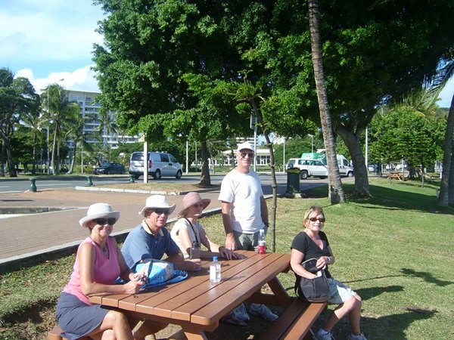
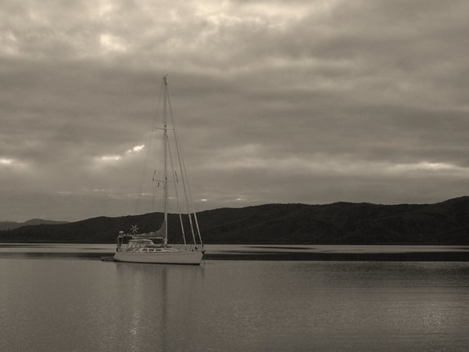

.This is a huge island and it is mostly surrounded by reefs so navigation is interesting.The French are digging out nickel every where and making the most of it before the referendum for independence in a few years.
From here we will sail to Vanuata and then to Queensland. We decided to take it easy this year and see some more of this area before heading home.Many boats are sailing via Capetown with insurers unhappy about the Somalian pirates so we have time to see how that develops.We would prefer to transit the Suez and spend some time in Turkey.

June 2009

Well the best laid plans of mice and men……We visited the Bay de Prony on the south end of the island and spent several days tramping round islands, visiting light houses on headlands and having a very sociable time with our friends on Aurielle. Unfortunately as we sailed to Yate on the east coast our foresail sheet traveler failed and the boom swung foreward shearing the gooseneck fitting.We did make Yate for the night and a good game of bridge but the next day we roared off back to Nouema in a strong trade wind to seek the help of a welder. Repairs took several days so we then headed up the west coast with the intention of belatedly joining the island tour in the North Lagoon. Lack of wind gave us pleasant days in Baie St Vincent where we anchored with a New Zealannd boat called Martin d”Or,a 48foot Westerley.
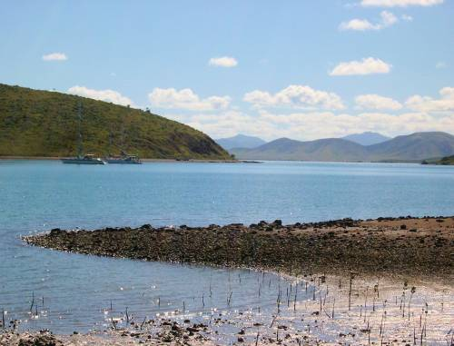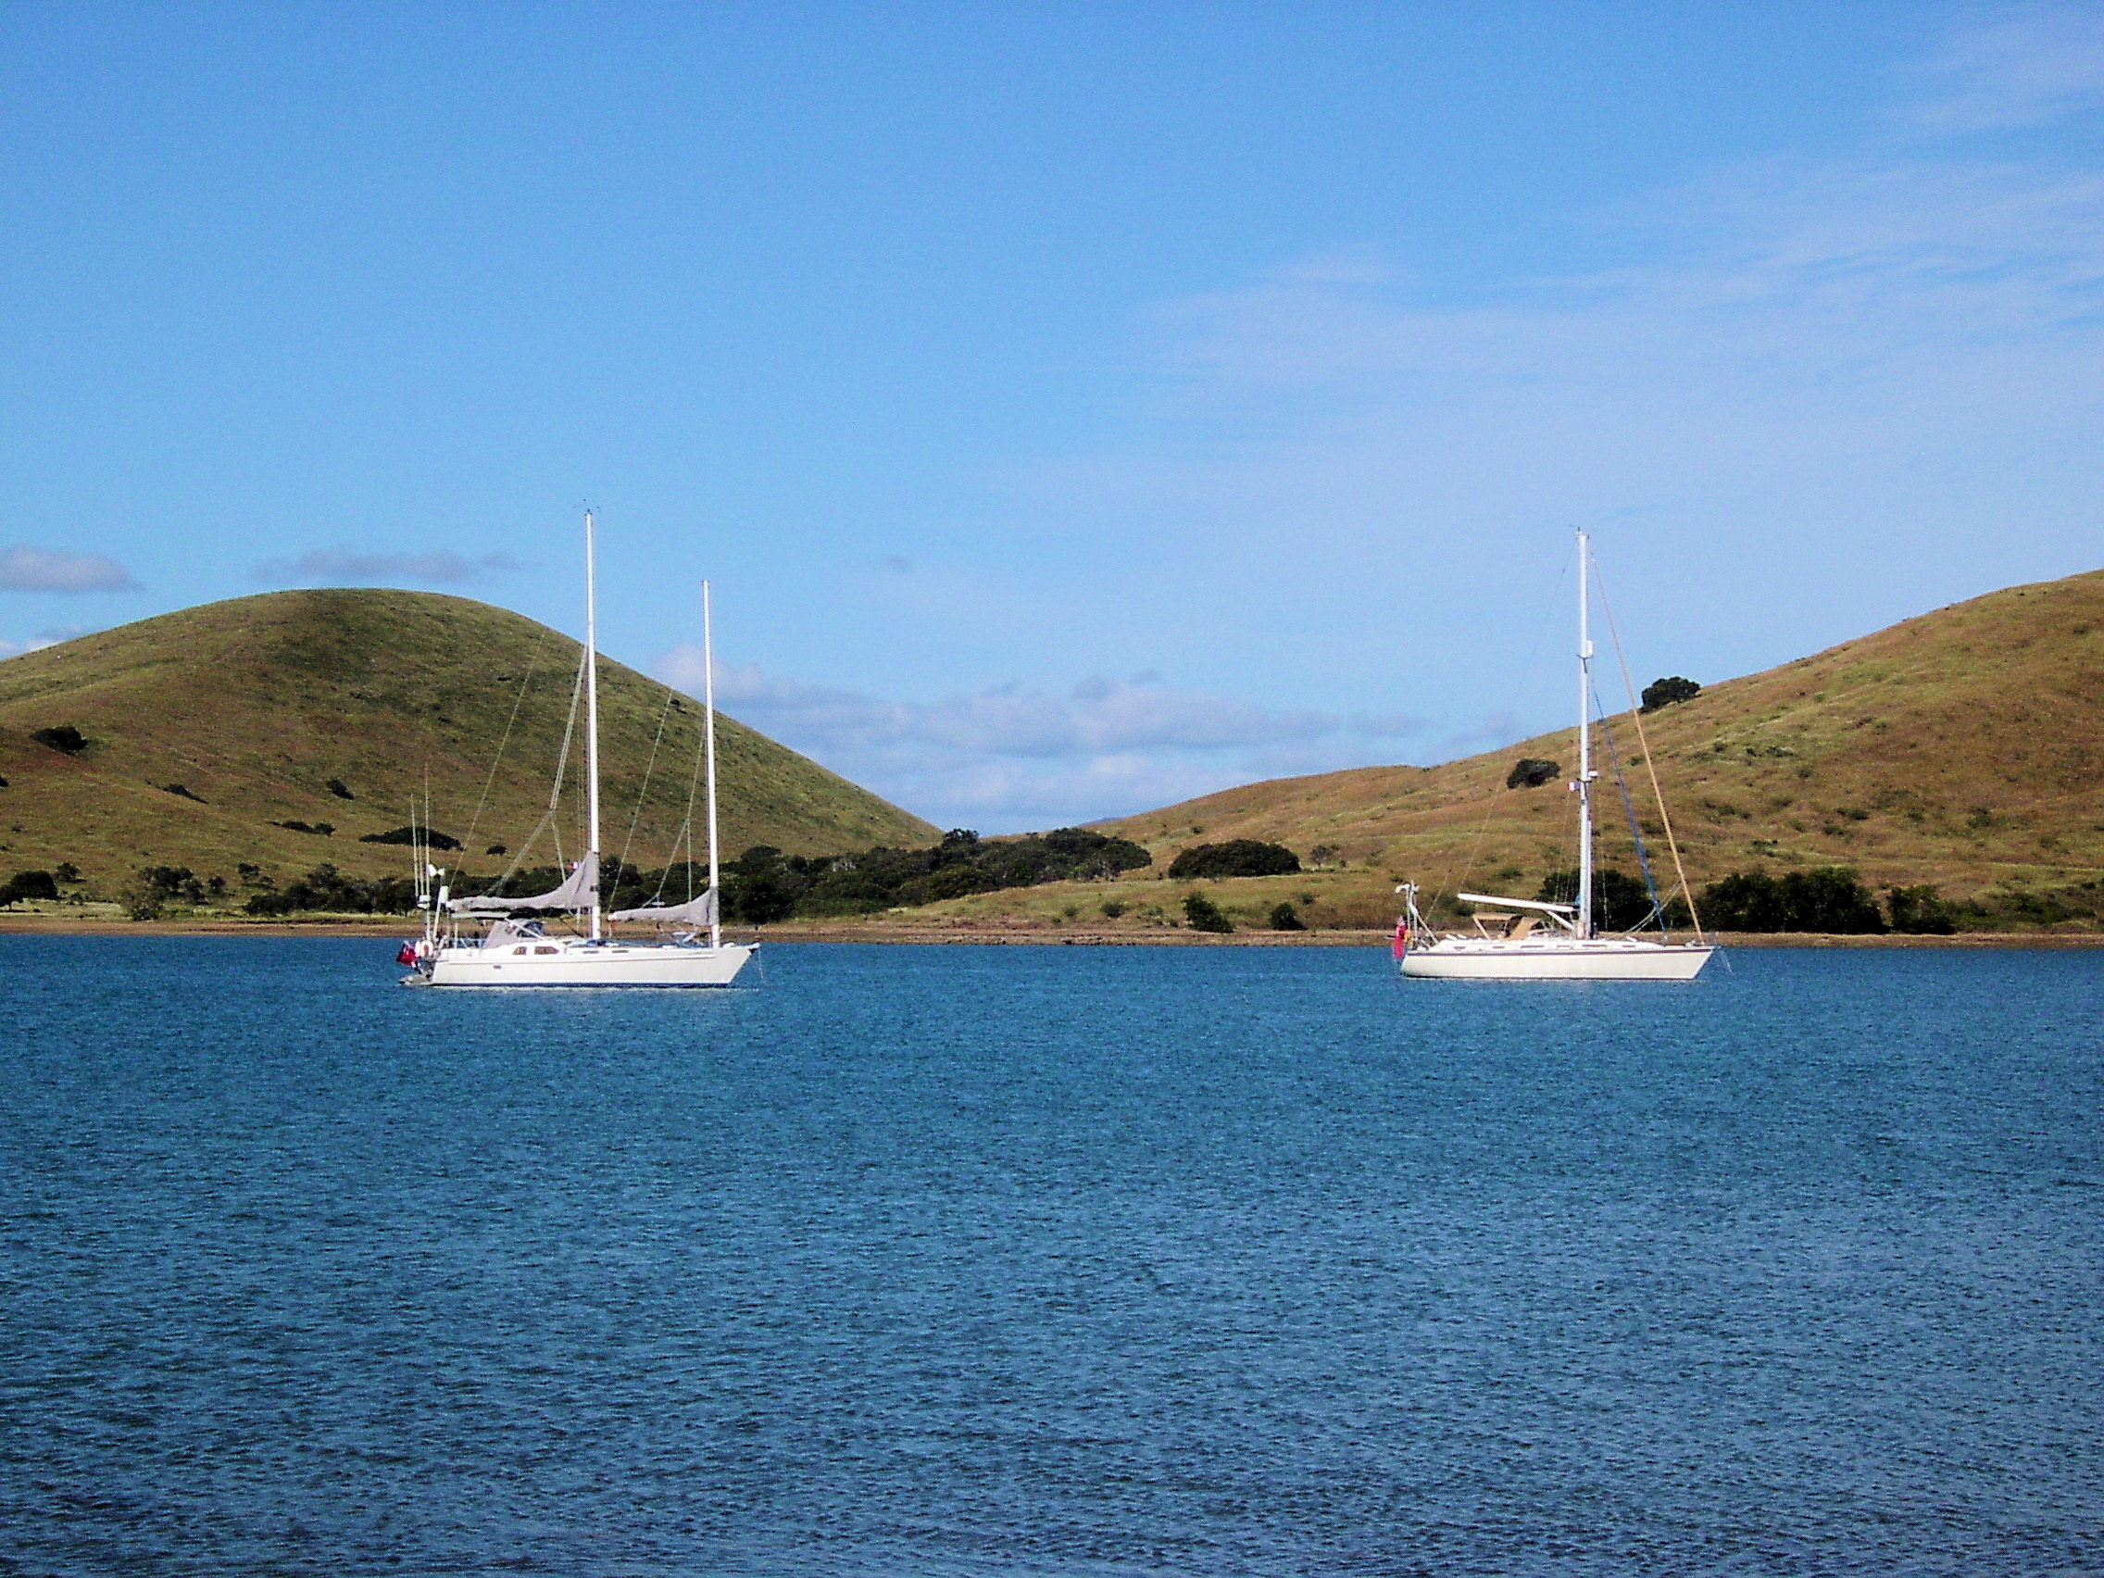

We enjoyed energetic walks and good natured games of scrabble or dvds in the evenings together. We then set off for Koumec 120 miles north near the top of the island where we planned to meet up with Aurielle. Fate seems to be against this exploration and as we motored through a narrow pass into the big blue we realized that our alternator had died. We returned belatedly to the anchorage and soon diagnosed a fault in the windings---so back to Nouema to buy another !
Life was enlivened when Lu and Rod turned up from New Zealand in Skylax and some good celebrations were had.
Our island tour was obviously doomed so we returned to the Bay de Prony with Courtesan (A Melbourne boat) and spent a couple of days at Isle Casey and the Careenage while a trough cleared the area. We then sailed the 210 miles to Vanuata and anchored in Resolution Bay (used by Capt.Cook ) in the island of Tanna. A very fast trip under reefed main alone as we needed daylight to get into the bay and once more found the wind in excess of the forecast.

July 2009

Vanuata is another world. Completely unspoilt and very beautiful. The 2 hour drive to clear customs ,immigration and quarantine on the east coast is an adventure in itself. At one stage there were 17 people in the back of our pickup. You may not believe this but it is true and the track is very rough and rutted—4wheel drive only!! The same truck took us to see the active volcano one evening. We stood on the rim and were gobsmacked as it through hundreds of tons of red hot larva up into the sky every few minutes.This was accompanied with an earthshaking roar which had us very concerned at first.We heard later that the volcano is relatively quiet at the moment. Health and Safety in the UK or US would have had us a mile away!!
Although the people have very little material wealth the area is very fertile and the people look well fed and are very cheerful. Their homes are very tidy and use materials at hand with thatched roofs, woven reed walls on timber frames. The villages have schools and churches (sometimes imported prefabrications and sometimes of traditional construction.)The vegetable gardens are extensive and healthy cattle and pigs abound.
-----more smiling faces than on the streets of London or Sydney too!------

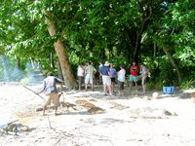
We enjoyed a pigroast one day on the beach at the anchorage which gave us a chance to meet the crew of the other 9 yachts anchored nearby it was good to be with a group for a day or so and meet people we talk on the net to.We often have the anchorages to ourselves but of course the local people make us welcome as yachts probably account for the majority of visitors here

At another village,Sally, the chief’s wife, showed us their hot springs where boiling water comes out of the ground.I some clay patches nearby the heat in the ground breaks up the clay into many colours---used for face painting apparently. .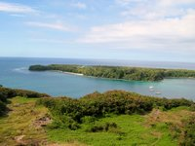 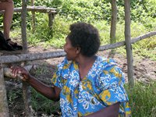

We then had a calm daysail some 50 miles up to Erromango and anchored in Dillon Bay,open to the west but very sheltered from the east trade winds.A trip ashore was very enjoyable and we were shown around the small village by Micheal.We were able to pass on some of the many clothes donated by Opua School in NZ as the folk here have very few material possessions. This village suffers some notoriety as some missionaries were killed and eaten here in the late 19th centuary. The poor folk were blamed for an outbreak of malaria and other infections!!!
The next port of call was Port Villa on Efate.This is the capitol and was soon reached in an overnightsail with a fresh 25-30 wind up our tail. A very sheltered anchorage here is a gathering spot for yachties and a chance to go shopping for provisions.We are not far from the bungee jumping island of Pentacost and are planning an itinary for Mark and Mel’s coming visit next week.

