26-29/01/2012 USVI Distance: ~20nm

”18:19N 64:51W”

We were looking forward to the comforts of the IGY marina in Cruz Bay, so we were somewhat taken aback by the lack of laid moorings. The marina manager apologized, saying that this was the best he could find for three months, till the departure of the transport ship taking Fenix back to the Med. We set up a veritable spider web of mooring lines tied to the two piles on the two sides of the boat and to the rickety jetty. Hopefully they will cope with any storms and keep Fenix safe!
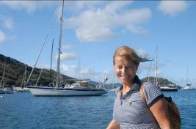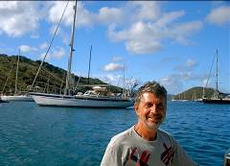

As our batteries were flat we were looking forward to plug in into shore power. But we soon realized that we forgot about the obvious: in USVI electricity was 115 Volts. So we bought a car battery charger and Steve built a long extension cord using a special plug that fitted the power point on the jetty.

We spent the next three days packing up the boat and trying to outsmart the rain. By the time we finished we were quite exhausted and were really ready for civilization. We flew to San Francisco where we spent two gorgeous days and had a great dinner with Anna, Dan and Dookie (their lovable dog). Then we flew to Melbourne where we spent 4 days with Gavin, Susie and Pungie (their beautiful cat). As a combined Xmas and B’day present they took us to the Hepburn Bathhouse and spa near Daylesford, a wonderful hot spring rich in minerals. I should not forget about the superb lunch that followed. Just, what the doctor ordered for the tired crew of Fenix.
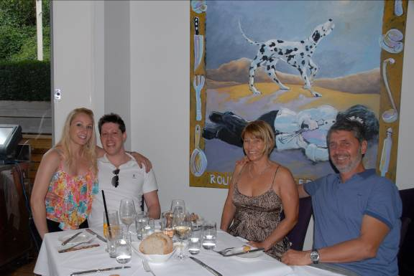

Then, it was back to Perth, returning to normality.

Sailing in the Caribbean was interesting, exciting and very different from what we imagined. The little bays and sandy beaches surrounded by volcanic mountains are breathtakingly beautiful and sailing was great. But the marinas and the luxury resorts are totally disconnected from the poverty that surrounds them, which we found somewhat disconcerting.

We are glad that we did the Atlantic crossing and had a chance to explore such far away lands. But I think this year’s sailing was a bit hectic with too much happening every day, not as relaxing as we would have liked it.

