25/01/2012 BVI, Tortola, West End Distance: ~110nm

“18:23N 64:42W”

It was another beautiful afternoon, perfect for sailing. We were making way at a speed of 6.5-7.0 knots. By late afternoon we caught up with a beautiful 100 foot replica tall ship sailing boat with square rigging. We took photos and had a sundowner. The golden coloured Tokaj wine reflected brightly the golden sunset. Life was good.
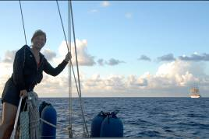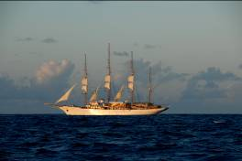

As we looked around in the twilight we realized the first time that there were more than two boats heading the same direction. As a matter of fact there were so many boats around us that we were traveling on something like a highway to BVI. They all wanted to arrive in the morning, so regardless of capabilities the large cruiseships with their thousands of HP engines, the 100 foot yachts, the motorboats and the small sailing boats were all traveling at the same speed. It was really funny that on this large ocean we all came together like a caravan.

I noticed that on our port side there were four cruseships within a couple of nautical miles from each other. By this time we were traveling on a broad reach, with the main and the genoa. I collected the gear for my turn of the night watch; put on some warm clothing, tied my harness lanyard to the cockpit floor and enjoyed the night sky. As always I was trying to make sense of all those twinkling stars hopelessly trying to work out the different constellations.

Then, I noticed that one of the cruiseships a couple of nms behind us slowly closed up and in half an hour or so it was about 3 nm off our starboard side, sailing parallel with us.

The wind direction was shifting and our course became more and more broad reach. If we wanted to keep the genoa flying we inevitably got closer and closer to the cruise ship. When the distance between us became less than 1nm they started to flash their search light and called us on the VHF radio. Not that we could have missed them. The ship was gloriously lit. Even some sort of light show was happening as some of the levels were regularly changing colours. By now the cruiseship was so close that it felt like sitting in the middle of fireworks.

The conversation was something like this;
“Fenix, Fenix this is Norwegian Gem. Do you copy?
Norwegian Gem this is Fenix.
Chanel 10.
Switching to Chanel 10
Fenix, you are getting very close to us.
Norwegian Gem we know. But the wind direction has changed and we cannot keep 295ºanymore. We have to sail at 305o. Can you cross over behind us?
Hahaha. No, Under no circumstances we can change direction.
Then, what do we do?
I guess do your best and we monitor the situation.
Roger that, we do our best. Fenix standing by on Ch16

We set in the cockpit speechless. I am a brave girl. I am not scared of big swell, huge waves, heeling till the deck is under water but I am positively terrified of large ships. I am painfully aware that a cruiseship like this even with full “breaks” cannot stop within miles and can run over us without any of the guests or the crew for that matter ever noticing that something happened.
So I was “monitoring” the situation that was worsening by the minute and becoming quietly terrified at the same time. After about ten minutes Steve who, no surprises here, was also “monitoring” asked for the radio again.
I called the cruise ship.

Norwegian Gem this is Fenix, Fenix Do you copy.
Fenix, this is Norwegian Gem Channel 10.

Steve took over the radio.

Norwegian Gem we understand that you cannot change direction but can you speed up for a short time? Then we can cross over to your starboard side.
Fenix, that’s a good idea. We will do it. Over.

Indeed they sped up to 16 knts, we went up behind them and in half an hour we were comfortably sailing at a bearing of 301º on their starboard. Now, this was funny. Steve from a small boat advising the captain of a ship more than 300m long and 6 story high how to avoid colliding with us!

Around the same time there was a tragic cruiseship accident at the coast of Italy. The crusieship was 3nm out of course and ran into a rock that cut a huge hole into her side. It was a miracle that only 30 or so passengers died from the more than 4000 people on board. The captain must have gone to the same school as the captain of the Norwegian Gem!

Now, fully aware of the capabilities of the Norwegian Gem crew I was really terrified. Particularly, that I worked out on the chart that their bearing of 295 º runs straight into an island. Thus sooner or later they will have to start coming up towards us. On the other hand our destination was on their port side. By this time the wind direction changed and we could sail at 295 º with around 7.0 knots. I continued my watch mesmerized by the lights of the Norwegian Gem sailing silently beside us like the Evil Empire. Remember Star Wars? I kept my watch and tried to avoid the fishing boats coming up on our radar with quite a frequency (who on earth was fishing in more than 200m deep waters??).

Indeed around 4 am the cruiseship started to change direction. I did a projection on the map and came to the alarming conclusion that they intended to make the entry to Tortola bay through a narrow passage and, unfortunately for us, in the process they will push us onto one of the nearby islands. At this point I woke Steve up.
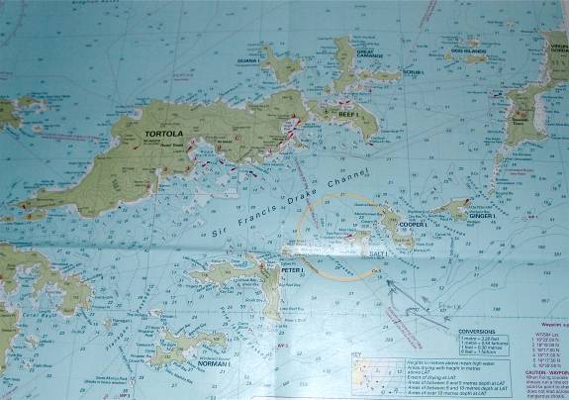

He studied the situation and decided that, as we were already ahead of the ship which was doing about 7 knots, we should be able to go across in front of their bow. We would switch on the engine, motor-sail, and run for our lives. This was not a popular decision with me. But I have to admit that the alternatives, like a short handed jibe in 25-30 knots in the pitch dark was even less popular. So, grudgingly I switched on the engine, praying that we will not have an engine failure or any problems with the sails while we were crossing in front of the huge cruiseship. I am writing this blog, so it means that we made it, motor-sailing at our top speed of about 8-9knots, with not much more that 1 nm between us at the closest point.

We were heading towards the channel to the most Western bay on the island of Tortola appropriately named, West End. The channel was narrow so at first light we did couple of Dutch jibes to bring Fenix into the right position for crossing the narrow channel. We arrived at 7 am to West End and anchored in 20m water.

I love night passages when we are alone in the middle of the ocean and I can enjoy the solitude that is so rare and precious in this crowded world. However this was anything but a quiet night for meditation. Usually after a night passage we normally have a day or two on anchor, recuperating from a night on watch.

This time it could not be. In this world, where a few idiots can ruin the life of billions of people, the USA customs and immigration has become extremely vigilant. They came up with a truly incredible, absolutely nonsensical rule for people arriving to the USA on yachts. People who carry visa wavers like us, traveling on an Australian passport, can only enter into the USA on an “approved carrier” like a ferry from Tortola, BVI to USVI, Cruz Bay. To cut a long story short to end up in the IGY Marina in Red Hook Bay where Fenix will be picked up by the delivery captain in April we had to jump through the following hoops:

Immigration/Customs BVI In
Immigration/Customs BVI Out

Take the Ferry from West End to Cruz Bay

Immigration/Customs USVI In

Spend 3 hrs at Cruz Bay (not a very nice place)

Immigration/Customs USVI Out

Take the Ferry from Cruz Bay to West End

Immigration/Customs BVI In

We spent the night at West End. Actually West End was delightful place. Nice stately houses hidden among the trees, a lovely marina and a superb pub overlooking the bay. The pub not only served great cocktails and beer but the world’s best chips. It looked like a serpentine, thin and crispy. Totally wonderful! We also visited the Pusser’s shop. Pusser was a British Admiral who infamously introduced grog ie. making it compulsory to dilute the sailor’s rum portions with water in the navy. There was a shop named after him selling Pusser’s unbreakable tin mugs and outfits that would have delighted Simon Templar. For those who have not heard of him, Simon Templar, played by Roger Moore, was a character in a thriller during the 60-70s.
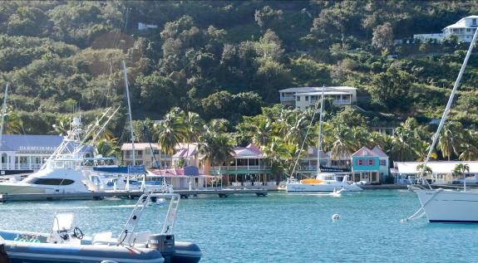

Next morning we sailed to Cruz Bay, USVI

Immigration/Customs BVI Out
Immigration/Customs USVI In (greeted by customs officers from the day before)

And finally after another half an hour sail we arrived to our final destination the IGY marina. It was easy. Wasn’t it?

