19-22/12/2011 Iles des Santes Distance: ~93 NM

15:52N 61:35W”

We planned to leave at 6.00 in the morning for the 93 nm trip. Unfortunately our departure was delayed by an hour as our towing generator (new in 2010) needed some repair. But we were off soon and the reliable trade-winds carried us smoothly along the island while we were adoring the interesting volcanic landscape. I have to say that sailing in the Caribbean is incomparable to any location where I sailed before. Around Perth the weather is reliable, you can set your watch to the arrival of the Fremantle doctor with its 15-25 knots S/W wind but the conditions can become harsh quickly. It is always a challenging sail along the Western Australian coast. The Mediterranean wind is unreliable. The wind turns quickly, dies down, sometimes katabatic, other times non existent. Sailing in the Caribbean is not only perfect in every sense but outrageously beautiful.
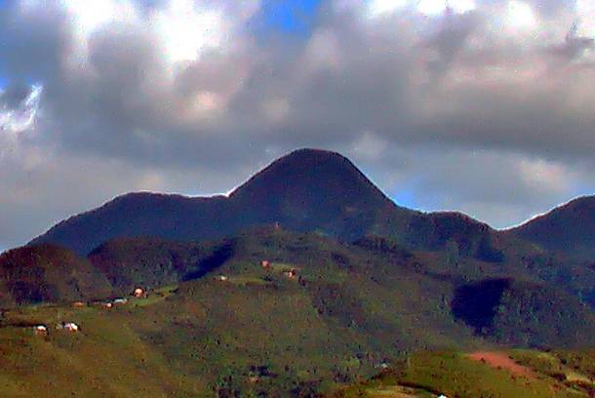
We reached the end of Martinique at around lunch time and passed into the channel between Martinique and Dominica. We entered the waters piling up in between the two islands and started to experience the Atlantic swell. Not unpleasant when one sails on reach but sometimes a very wet experience, with waves occasionally pouring into our center cockpit. By the time we reached the most Southern edge of Dominica the wind died, giving us a chance to recover our towing generator that failed again, with a broken pin. After a short break the wind recovered and we continued our sailing. Dominica has majestic high mountains over 1500 meters high that are covered with thick rain forest. Sometimes the peak has a vertical drop to the valley under creating spectacular scenery with clouds covering the peak, rainbow in the valley and the whole picture changing continuously like in a movie. The wind strengthened to 20-25 knots and we were traveling fast with 8.0-8.5 knots towards our destination, the beautiful Iles des Saintes. In the Caribbean night falls early and it gets dark after 18.00. At this point we were at least 25 nm from our destination and sailing, particularly after we left the protective Western shores of Dominica, became quite challenging. Large waves and 25 knot wind. Not a good combination. We furled the main and continued our trip under the genoa.

At this point I became quite stressed as the entrance to the anchorage was very narrow
(300m) between an island and the reef and we had large swell and complete darkness. No moon or stars helped us to make our entrance more comfortable. We have a backup chart plotter at the navigation table, but our PC based display in the cockpit was out of order thus the entry with a short handed crew of 2 (Steve and myself) was not a comfortable thought. After taking a big breath we powered through the gap into a lovely anchorage where we spent the next day contemplating the world. The little bay was home to a large colony of Frigate birds. These are fairly large grayish creatures that resemble birds from the dinosaur era. They are incredible hunters with amazing eyesight. We watched them for hours as they fished and returned to their tree nests to feed their chicks. Sometimes they landed on rocks just meters from us to dry their feathers. I was surprised to see how large they were. They looked totally out of place on the tree tops. Some trees were carrying 5-10 nests. What an entertainment!
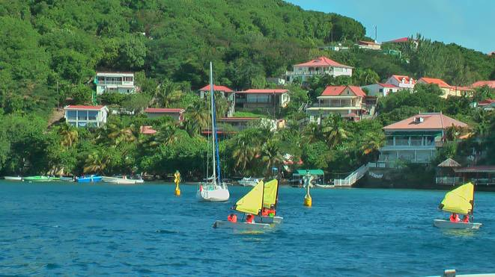
The following day we sailed to Iles des Saintes’ “capital” and only town Bourg de Santes. This place is an absolute delight. It is exactly the picture perfect paradise. No wonder that they are called the Islands of the Saints. Obviously God favored his saints and gave them the best place on Earth. I like sandy beaches and palm trees but I am an absolute sucker for small French seaside towns. I could spend here weeks, months or years. It is clean, beautiful; the food is divine and the water is irresistible.

After a short walk into town I dived from the boat and experienced something never I felt before. I love swimming but have difficulties with getting into cold water. When I say cold I consider the water around Perth cold. I dive, swim but I always have to have long discussions with myself how good it will be once I manage to get through the first couple of strokes. Here, I dived and it was like never before, warm water caressing smoothly not even that salty. I frolicked around Fenix for 15 minutes like a child. In Australia there are Christmas Pagaens and Carols in Bourg de Saintes there is a Xmas street party with one of the outstanding Caribbean band providing the music. But later and more about Caribbean music.

